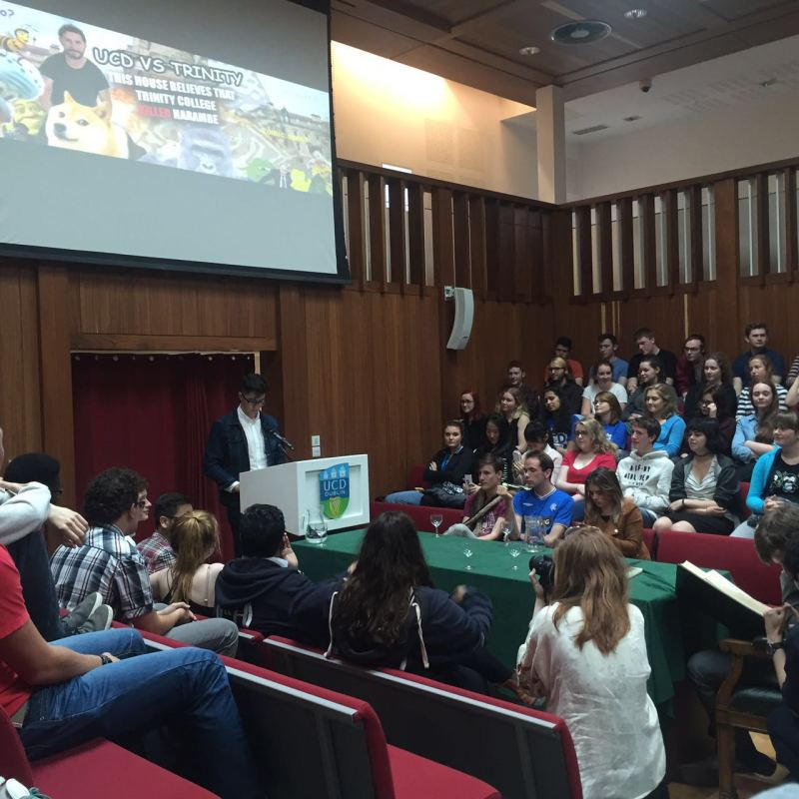

UCD

<https://www.google.com/url?sa=i&url=https%3A%2F%2Fwww.studyabroad101.com%2Fprograms%2Funiversity-college-dublin-dublin-direct-enrollment-exchange%2Freviews%2F36296&psig=AOvVaw37tIxQKxKTyK5hXHEpV4uR&ust=1670922624225000&source=images&cd=vfe&ved=0CBAQjRxqFwoTCLC-zf_d8_sCFQAAAAAdAAAAABAE>

TCD

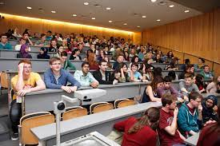



<https://www.google.com/imgres?imgurl=https%3A%2F%2Fwww.tcd.ie%2FEnglish%2Fassets%2Fimg%2Fstudents-learning%2520lecture.jpg&imgrefurl=https%3A%2F%2Fwww.tcd.ie%2FEnglish%2Fundergraduate%2F&tbnid=066Fp6CM1xggnM&vet=12ahUKEwiq2Mac3vP7AhUEokwKHYmGDS4QMygAegUIARDCAQ..i&docid=XcQ6ig4NiV7hHM&w=3600&h=2400&q=Trinity%20college%20dublin%20classes&ved=2ahUKEwiq2Mac3vP7AhUEokwKHYmGDS4QMygAegUIARDCAQ>

NCI

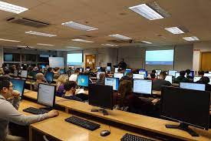 

https://www.google.com/url?sa=i&url=https%3A%2F%2Fstudyabroad.shiksha.com%2Fireland%2Funiversities%2Fnational-college-of-ireland&psig=AOvVaw2HEEGd1fPXWd7DzLD8TSiJ&ust=1670922806952000&source=images&cd=vfe&ved=0CBAQjRxqFwoTCPii7dbe8_sCFQAAAAAdAAAAABAE

<https://www.google.com/imgres?imgurl=https%3A%2F%2Fwww.ncirl.ie%2FPortals%2F0%2FImages%2F450x253-Cards-Teasers%2Fimg-students-undergraduates-at%2520NCI-entrance.jpg&imgrefurl=https%3A%2F%2Fwww.ncirl.ie%2FStudy%2FAll-Courses&tbnid=8TTlVtUSJJbk5M&vet=12ahUKEwiBv47U3vP7AhXigc4BHep8CIIQMyg3egQIARBM..i&docid=FCcaDpcHukYiaM&w=450&h=253&q=National%20college%20of%20Ireland%20classes&ved=2ahUKEwiBv47U3vP7AhXigc4BHep8CIIQMyg3egQIARBM>

DCU

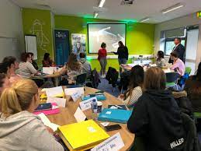

<https://www.google.com/imgres?imgurl=https%3A%2F%2Ftudublin.ie%2Fmedia%2Fwebsite%2Fstudy%2Finternational-students%2Ftu-dublin-summer-school%2Fimages%2Fsummer-school-classroom-orig.jpg&imgrefurl=https%3A%2F%2Ftudublin.ie%2Fstudy%2Finternational-students%2Ftu-dublin-summer-school%2Fcourse-overview%2F&tbnid=Dnpp7d4vuyIDmM&vet=12ahUKEwiWvuKC3_P7AhVNU6QEHQO0AMkQMygBegUIARC_AQ..i&docid=IxNuMkpp6dzvlM&w=1067&h=800&q=TU%20dublin%20classes&ved=2ahUKEwiWvuKC3_P7AhVNU6QEHQO0AMkQMygBegUIARC_AQ>

TUD

 <https://www.google.com/imgres?imgurl=https%3A%2F%2Fwww.tudublin.ie%2Fmedia%2Fwebsite%2Fimages%2Ffeature-box%2Fculinary-arts-feature.jpg&imgrefurl=https%3A%2F%2Fwww.tudublin.ie%2Fexplore%2Ffaculties-and-schools%2F&tbnid=8WBsFESA1_MPBM&vet=12ahUKEwiWvuKC3_P7AhVNU6QEHQO0AMkQMyg6egQIARBW..i&docid=IRBCgXRG6LL-ZM&w=310&h=310&q=TU%20dublin%20classes&ved=2ahUKEwiWvuKC3_P7AhVNU6QEHQO0AMkQMyg6egQIARBW>

DCU

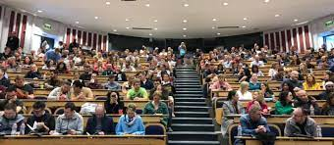

<https://www.google.com/imgres?imgurl=https%3A%2F%2Fni4dl.files.wordpress.com%2F2018%2F10%2F21.jpg%3Fw%3D900&imgrefurl=https%3A%2F%2Fnidl.blog%2F2018%2F10%2F02%2Flarge-turnout-for-welcome-day-for-new-dcu-connected-online-students%2F&tbnid=K71kMemqLpyJuM&vet=12ahUKEwictcXl3_P7AhUwUqQEHagnAWEQMygIegUIARDIAQ..i&docid=6-_GR6FnKUqkhM&w=900&h=394&q=DCU%20classes&ved=2ahUKEwictcXl3_P7AhUwUqQEHagnAWEQMygIegUIARDIAQ>



<https://www.google.com/imgres?imgurl=https%3A%2F%2Fwww.dcu.ie%2Fsites%2Fdefault%2Ffiles%2Fstyles%2Fwidescreen_television%2Fpublic%2Fmedia%2F2019%2F09%2F05%2Flg-phd-programme_web.jpg%3Fh%3Df5eaf8c1%26itok%3Dw4bkNd90&imgrefurl=https%3A%2F%2Fwww.dcu.ie%2Flawandgovernment&tbnid=flM8PT5optHb1M&vet=12ahUKEwictcXl3_P7AhUwUqQEHagnAWEQMygfegUIARD7AQ..i&docid=DLQXAfcQhwdqoM&w=823&h=463&q=DCU%20classes&ved=2ahUKEwictcXl3_P7AhUwUqQEHagnAWEQMygfegUIARD7AQ>

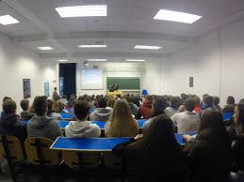

<https://www.google.com/imgres?imgurl=http%3A%2F%2Faorty.weebly.com%2Fuploads%2F6%2F4%2F6%2F8%2F64689335%2F3783860_orig.jpg&imgrefurl=https%3A%2F%2Faorty.weebly.com%2Fextra-curricularpastime-activities%2Fdcu-open-day&tbnid=bVhuqzaD507TPM&vet=10CFoQMyiQAWoXChMI6NiC6N_z-wIVAAAAAB0AAAAAEAM..i&docid=EKErJZCHGLiyuM&w=1066&h=800&q=DCU%20classes&ved=0CFoQMyiQAWoXChMI6NiC6N_z-wIVAAAAAB0AAAAAEAM>

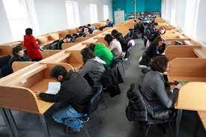

<https://www.google.com/imgres?imgurl=https%3A%2F%2Fimages.shiksha.com%2Fmediadata%2Fimages%2F1539770505phprd6yct.jpeg&imgrefurl=https%3A%2F%2Fstudyabroad.shiksha.com%2Fireland%2Funiversities%2Fgriffith-college&tbnid=IljIa4DkHZx2SM&vet=12ahUKEwi11PC74PP7AhWOV6QEHU58CfIQMygDegUIARDCAQ..i&docid=XZ2TyKxJqaLKvM&w=600&h=400&q=griffith%20college%20classes&ved=2ahUKEwi11PC74PP7AhWOV6QEHU58CfIQMygDegUIARDCAQ>

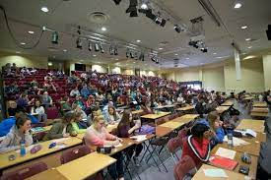 <https://www.google.com/imgres?imgurl=https%3A%2F%2Fimages.shiksha.com%2Fmediadata%2Fimages%2F1539770504phpjLrkiF.jpeg&imgrefurl=https%3A%2F%2Fstudyabroad.shiksha.com%2Fireland%2Funiversities%2Fgriffith-college%2Fcourses&tbnid=RB1lEOJ-fdm_qM&vet=12ahUKEwi11PC74PP7AhWOV6QEHU58CfIQMygCegUIARDAAQ..i&docid=POntGP7xuWeXZM&w=600&h=400&q=griffith%20college%20classes&ved=2ahUKEwi11PC74PP7AhWOV6QEHU58CfIQMygCegUIARDAAQ>

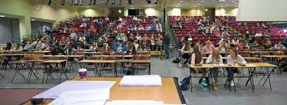

<https://www.google.com/imgres?imgurl=https%3A%2F%2Fwww.easyuni.in%2Fmedia%2Finstitution%2Fphoto%2F2019%2F08%2F01%2FStudentsin-Auditorium_1.png.600x400_q85.png&imgrefurl=https%3A%2F%2Fwww.easyuni.in%2Fireland%2Fgriffith-college-dublin-10001%2F&tbnid=WpApkXc5RAdBPM&vet=10CDIQMyh-ahcKEwjIus2-4PP7AhUAAAAAHQAAAAAQAw..i&docid=oGWLer1PqII_0M&w=600&h=222&q=griffith%20college%20classes&ved=0CDIQMyh-ahcKEwjIus2-4PP7AhUAAAAAHQAAAAAQAw>

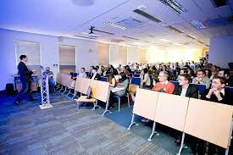 <https://www.google.com/imgres?imgurl=https%3A%2F%2Fimages.shiksha.com%2Fmediadata%2Fimages%2F1505732463php27TVZr.jpeg&imgrefurl=https%3A%2F%2Fstudyabroad.shiksha.com%2Fireland%2Funiversities%2Fdublin-business-school&tbnid=Gfzgk-HgDJEVHM&vet=12ahUKEwjq7aDB4fP7AhWOpycCHYmpDQQQMygCegUIARDFAQ..i&docid=UgSCuMdgUI5GUM&w=600&h=400&q=dublin%20buisness%20school%20classes&ved=2ahUKEwjq7aDB4fP7AhWOpycCHYmpDQQQMygCegUIARDFAQ>

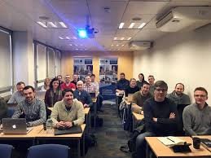

<https://www.google.com/imgres?imgurl=https%3A%2F%2Flookaside.fbsbx.com%2Flookaside%2Fcrawler%2Fmedia%2F%3Fmedia_id%3D10155041953769431&imgrefurl=https%3A%2F%2Fm.facebook.com%2FDublinBusinessSchool%2Fposts%2F10155041993714431&tbnid=ZmVSqUiDNbFI_M&vet=12ahUKEwjq7aDB4fP7AhWOpycCHYmpDQQQMyhAegQIARBg..i&docid=aaK3fpfZ7eal4M&w=2048&h=1536&itg=1&q=dublin%20buisness%20school%20classes&ved=2ahUKEwjq7aDB4fP7AhWOpycCHYmpDQQQMyhAegQIARBg>

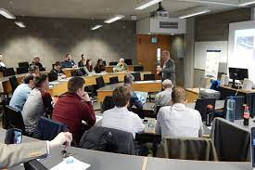

<https://www.google.com/imgres?imgurl=https%3A%2F%2Fimages.shiksha.com%2Fmediadata%2Fimages%2F1535457468phpW7fi5t.jpeg&imgrefurl=https%3A%2F%2Fstudyabroad.shiksha.com%2Fireland%2Funiversities%2Funiversity-of-limerick&tbnid=UWv79B9ISR79yM&vet=12ahUKEwjCgumD4vP7AhVtVaQEHTWtD94QMygCegUIARDFAQ..i&docid=gOOqIC-8hTqBRM&w=600&h=400&q=University%20of%20limerick%20classes&ved=2ahUKEwjCgumD4vP7AhVtVaQEHTWtD94QMygCegUIARDFAQ>

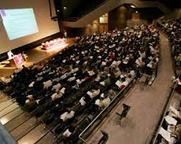

<https://www.google.com/imgres?imgurl=https%3A%2F%2Fcampuslife.ul.ie%2Fmedia%2FConcert%2520Hall%2520Conference_300x240.jpg&imgrefurl=https%3A%2F%2Fcampuslife.ul.ie%2F&tbnid=i92SLQLXqG-ySM&vet=12ahUKEwjCgumD4vP7AhVtVaQEHTWtD94QMygEegUIARDJAQ..i&docid=QGIA4WCF0lbzUM&w=300&h=240&q=University%20of%20limerick%20classes&ved=2ahUKEwjCgumD4vP7AhVtVaQEHTWtD94QMygEegUIARDJAQ>



<https://www.google.com/imgres?imgurl=https%3A%2F%2Fwww.limerick.ie%2Fsites%2Fdefault%2Ffiles%2Fstyles%2Fhero_image%2Fpublic%2Fmedia%2Fimages%2F2021-06%2Flecture-hall-810x456.png%3Fitok%3DCitYN9bp&imgrefurl=https%3A%2F%2Fwww.limerick.ie%2Fdiscover%2Flearning%2Flearning-options%2F3rd-level-institutions%2Funiversity-limerick&tbnid=SbykhXqrk5IFAM&vet=12ahUKEwjCgumD4vP7AhVtVaQEHTWtD94QMygIegUIARDRAQ..i&docid=2vSu9NwDmtcz1M&w=810&h=455&q=University%20of%20limerick%20classes&ved=2ahUKEwjCgumD4vP7AhVtVaQEHTWtD94QMygIegUIARDRAQ>

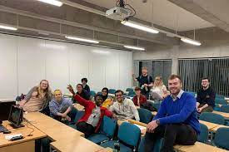

<https://www.google.com/imgres?imgurl=https%3A%2F%2Fwww.ittralee.ie%2Fen%2FInformationFor%2FCurrentStudents%2FStudentLife%2FSocieties%2Fgallery%2Fgallery6.jpg&imgrefurl=https%3A%2F%2Fwww.ittralee.ie%2Fen%2FInformationFor%2FCurrentStudents%2FStudentLife%2FSocieties%2F&tbnid=vasC_QPcPNmBUM&vet=12ahUKEwjM1M2l4vP7AhWIticCHaHwCWEQMygBegUIARDFAQ..i&docid=ggOgKBqKN0AO4M&w=960&h=640&q=Munster%20Technological%20University%20classes&ved=2ahUKEwjM1M2l4vP7AhWIticCHaHwCWEQMygBegUIARDFAQ>

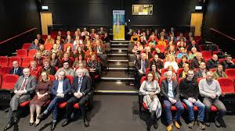

<https://www.google.com/imgres?imgurl=https%3A%2F%2Fwww.irishexaminer.com%2Fcms_media%2Fmodule_img%2F4546%2F2273193_11_seoimage16x9_HU9A4207.jpg&imgrefurl=https%3A%2F%2Fwww.irishexaminer.com%2Fopinion%2Fcommentanalysis%2Farid-40199322.html&tbnid=bdf0hNtpZ2UkXM&vet=12ahUKEwjM1M2l4vP7AhWIticCHaHwCWEQMygdegUIARCHAg..i&docid=QXvVtBG5AFSEIM&w=1200&h=675&q=Munster%20Technological%20University%20classes&ved=2ahUKEwjM1M2l4vP7AhWIticCHaHwCWEQMygdegUIARCHAg>

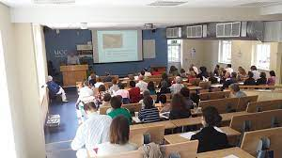

<https://www.google.com/imgres?imgurl=http%3A%2F%2Fstudyabroad.uni.edu%2F_customtags%2Fct_Image.cfm%3FImage_ID%3D16553&imgrefurl=https%3A%2F%2Funi.edu%2Fstudyabroad%2Fucc&tbnid=mScoE5XqTepoNM&vet=12ahUKEwjGhIDC4vP7AhURpicCHSzgAFoQMygBegUIARDBAQ..i&docid=iLhkfPDUJ-M68M&w=500&h=281&q=University%20College%20Cork%20classes&ved=2ahUKEwjGhIDC4vP7AhURpicCHSzgAFoQMygBegUIARDBAQ>

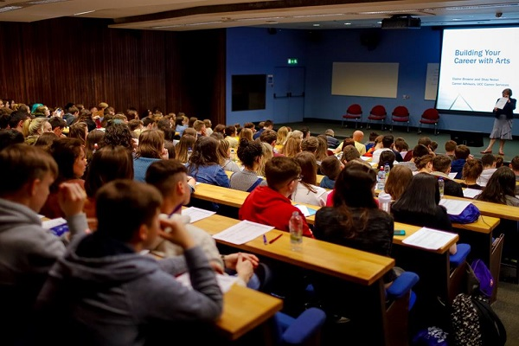

<https://www.google.com/url?sa=i&url=https%3A%2F%2Fstudyabroad.shiksha.com%2Fireland%2Funiversities%2Funiversity-college-cork&psig=AOvVaw2ZjgIhZ1wdry2d4VKPMvSS&ust=1670923842708000&source=images&cd=vfe&ved=0CBAQjRxqFwoTCKDFjsTi8_sCFQAAAAAdAAAAABAE>

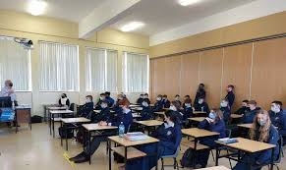

<https://www.google.com/imgres?imgurl=https%3A%2F%2Fsalesiancollege.ie%2Fwp-content%2Fuploads%2F2021%2F11%2F7697_20211117230823.jpeg&imgrefurl=https%3A%2F%2Fsalesiancollege.ie%2Ftus-engineering-talk-to-6th-years%2F&tbnid=Nj34vNwzbfJ-QM&vet=12ahUKEwirys3t4vP7AhXaVaQEHczYCPMQMyg6egQIARBU..i&docid=RKLpjYkHcnFXWM&w=960&h=573&itg=1&q=Technological%20University%20of%20the%20Shannon%20classes&ved=2ahUKEwirys3t4vP7AhXaVaQEHczYCPMQMyg6egQIARBU>

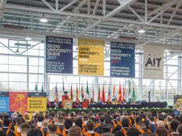

<https://www.google.com/imgres?imgurl=https%3A%2F%2Fwww.ait.ie%2Fimages%2Fmade%2Fuploads%2Fgeneral%2FGeneral_Graduation_Shot_GUG_2020_400_300_s_c1.jpg&imgrefurl=https%3A%2F%2Fwww.ait.ie%2Fnews%2Ffuture-students%2Fcampus-tours%2FP96&tbnid=bKkg1vYMo9gYqM&vet=12ahUKEwirys3t4vP7AhXaVaQEHczYCPMQMygIegUIARCNAQ..i&docid=PyEL1wjrC_824M&w=400&h=300&itg=1&q=Technological%20University%20of%20the%20Shannon%20classes&ved=2ahUKEwirys3t4vP7AhXaVaQEHczYCPMQMygIegUIARCNAQ>

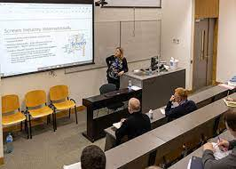

<https://www.google.com/imgres?imgurl=https%3A%2F%2Fwww.dkit.ie%2Fassets%2Fimage-cache%2Fuploads%2FISSS%2520Seminar%2520May%2520DkIT%2520420300.a25bf8f7.jpg&imgrefurl=https%3A%2F%2Fwww.dkit.ie%2Fnews%2F%3Farc_year%3Dindex.html%25253Farc_year%253D2019%2526arc_month%253D11.html%26page%3D6&tbnid=hE3NMuHzxktvxM&vet=12ahUKEwj5ndqz4_P7AhVOuScCHSmGDYkQMygGegUIARDIAQ..i&docid=NI0NWPmlcWqwGM&w=420&h=300&itg=1&q=Dundalk%20Institute%20of%20Technology%20classes&ved=2ahUKEwj5ndqz4_P7AhVOuScCHSmGDYkQMygGegUIARDIAQ>

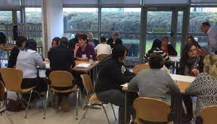

<https://www.google.com/imgres?imgurl=https%3A%2F%2Fwww.dkit.ie%2Fassets%2Fuploads%2FYouth%2520Work%25206.jpg&imgrefurl=https%3A%2F%2Fwww.dkit.ie%2Fcourses%2Fschool-of-business-and-humanities%2Fhumanities%2Fba-in-community-youth-work.html&tbnid=CS8K16DoJf6H7M&vet=12ahUKEwj5ndqz4_P7AhVOuScCHSmGDYkQMygBegUIARC-AQ..i&docid=0hEk3ZANVIwzTM&w=1402&h=801&q=Dundalk%20Institute%20of%20Technology%20classes&ved=2ahUKEwj5ndqz4_P7AhVOuScCHSmGDYkQMygBegUIARC-AQ>

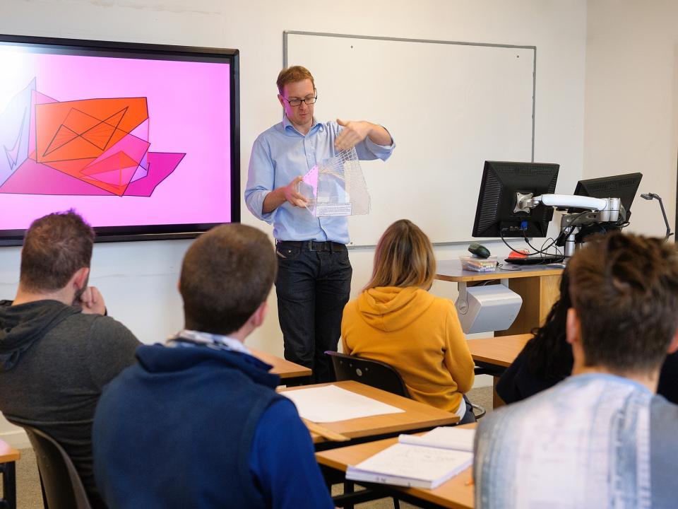

<https://www.google.com/url?sa=i&url=https%3A%2F%2Fwww.atu.ie%2Fjobs-at-atu&psig=AOvVaw1SWY6r3zIGIi2xtXgEuRnG&ust=1670924162957000&source=images&cd=vfe&ved=0CBAQjRxqFwoTCPjN89zj8_sCFQAAAAAdAAAAABAE>



<https://www.google.com/url?sa=i&url=https%3A%2F%2Fwww.atu.ie%2Fstudy-at-atu&psig=AOvVaw1SWY6r3zIGIi2xtXgEuRnG&ust=1670924162957000&source=images&cd=vfe&ved=0CBAQjRxqFwoTCPjN89zj8_sCFQAAAAAdAAAAABAO>

 <https://www.google.com/imgres?imgurl=https%3A%2F%2Fstorage.googleapis.com%2Fgweb-uniblog-publish-prod%2Foriginal_images%2FOption_05.jpg&imgrefurl=https%3A%2F%2Fblog.google%2Faround-the-globe%2Fgoogle-asia%2Fwhy-startups-are-thriving-in-south-east-asia-and-pakistan%2F&tbnid=qjtzlNpzwzPB7M&vet=12ahUKEwj97N_c5PP7AhX9cKQEHbIfDqkQMygwegUIARCrAg..i&docid=IkOg1_ao_s2L8M&w=4895&h=3268&q=South%20East%20Technological%20University%20classes&ved=2ahUKEwj97N_c5PP7AhX9cKQEHbIfDqkQMygwegUIARCrAg>

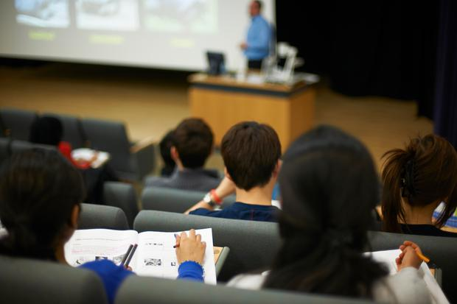

<https://www.google.com/url?sa=i&url=https%3A%2F%2Fwww.independent.ie%2Firish-news%2Feducation%2Funiversity-of-south-east-looking-likely-for-january-2022-40182498.html&psig=AOvVaw0zKtX5KwaYqSlddckr57y7&ust=1670924435675000&source=images&cd=vfe&ved=0CBAQjRxqFwoTCOiHi9_k8_sCFQAAAAAdAAAAABAE>

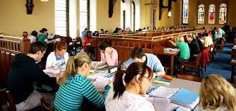

<https://www.google.com/imgres?imgurl=https%3A%2F%2Fres-3.cloudinary.com%2Fabroad101%2Fimage%2Fupload%2Fc_limit%2Cf_auto%2Ch_800%2Cw_800%2Fv1438931871%2FProgram_14628_ProfilePhoto__81fe.jpg&imgrefurl=https%3A%2F%2Fwww.studyabroad101.com%2Fprograms%2Fst-patrick-s-carlow-college-carlow-direct-enrollment-exchange&tbnid=5avc2dQtUiK-fM&vet=12ahUKEwi9jPWY5fP7AhXSoicCHTh9DjQQMygFegUIARDNAQ..i&docid=12-jbFyOA0AqzM&w=800&h=375&q=Carlow%20College%2C%20St%20Patrick%27s%20classes&ved=2ahUKEwi9jPWY5fP7AhXSoicCHTh9DjQQMygFegUIARDNAQ>

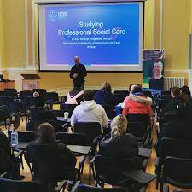 <https://www.google.com/imgres?imgurl=https%3A%2F%2Flookaside.fbsbx.com%2Flookaside%2Fcrawler%2Fmedia%2F%3Fmedia_id%3D2913391365470842&imgrefurl=https%3A%2F%2Fwww.facebook.com%2FCarlowCollegeStPatricks%2F&tbnid=kzKjYEVeNa5BoM&vet=12ahUKEwi9jPWY5fP7AhXSoicCHTh9DjQQMygIegUIARDVAQ..i&docid=gXnSYVYv3tza6M&w=1440&h=1440&q=Carlow%20College%2C%20St%20Patrick%27s%20classes&ved=2ahUKEwi9jPWY5fP7AhXSoicCHTh9DjQQMygIegUIARDVAQ>

 <https://www.google.com/imgres?imgurl=https%3A%2F%2Fbelltimemagazine.ie%2Fwp-content%2Fuploads%2F2021%2F09%2FEditoral_Bell_Time_Magazi-011.jpg&imgrefurl=https%3A%2F%2Fbelltimemagazine.ie%2Ftake-your-next-step-with-carlow-college%2F&tbnid=ZVWctT4St4VxdM&vet=12ahUKEwi9jPWY5fP7AhXSoicCHTh9DjQQMyhHegQIARB1..i&docid=f7eUCuFgwZ3KQM&w=836&h=559&q=Carlow%20College%2C%20St%20Patrick%27s%20classes&ved=2ahUKEwi9jPWY5fP7AhXSoicCHTh9DjQQMyhHegQIARB1>

 <https://www.google.com/imgres?imgurl=https%3A%2F%2Fkilkennynow.ie%2Fwp-content%2Fuploads%2FCarlow-College-Girl-in-library-.jpg&imgrefurl=https%3A%2F%2Fkilkennynow.ie%2Fsponsored-carlow-college-a-vibrant-campus-where-talented-staff-bring-a-personal-approach-to-every-student%2F&tbnid=XnqtjSAo2YgLVM&vet=12ahUKEwi9jPWY5fP7AhXSoicCHTh9DjQQMyhJegQIARB5..i&docid=en3x_aLPbkdGCM&w=612&h=408&itg=1&q=Carlow%20College%2C%20St%20Patrick%27s%20classes&ved=2ahUKEwi9jPWY5fP7AhXSoicCHTh9DjQQMyhJegQIARB5>

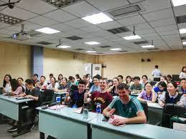 <https://www.google.com/imgres?imgurl=https%3A%2F%2Fwww.universityofgalway.ie%2Fmedia%2Fcollegeofartssocialsciencescelticstudies%2Fschools%2Fgeographyarchaeology%2Fhenam4.jpg&imgrefurl=https%3A%2F%2Fwww.universityofgalway.ie%2Fcolleges-and-schools%2Farts-social-sciences-and-celtic-studies%2Flanguage-literatures-culture%2Fchinese%2F&tbnid=6RnFrrEA88hvfM&vet=12ahUKEwi-ve3N5fP7AhWZUKQEHa0VAj4QMygAegUIARC8AQ..i&docid=hNtUL6hUG6ZiBM&w=4608&h=3456&q=NUI%20Galway%20classes&ved=2ahUKEwi-ve3N5fP7AhWZUKQEHa0VAj4QMygAegUIARC8AQ>

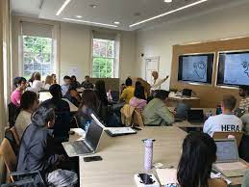 <https://www.google.com/imgres?imgurl=https%3A%2F%2Fnuig.ie%2Fmedia%2Funcategorised%2FPaula-Clarke-of-Clarke-Griffin-Associates.jpeg&imgrefurl=https%3A%2F%2Fnuig.ie%2Fcourses%2Ftaught-postgraduate-courses%2Finternational-marketing-entrepreneurship.html&tbnid=qDEB1mdSJn3pyM&vet=12ahUKEwi-ve3N5fP7AhWZUKQEHa0VAj4QMygBegUIARC-AQ..i&docid=fgmYyi-Ay7UD9M&w=2048&h=1536&itg=1&q=NUI%20Galway%20classes&ved=2ahUKEwi-ve3N5fP7AhWZUKQEHa0VAj4QMygBegUIARC-AQ>

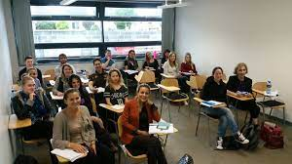 <https://www.google.com/imgres?imgurl=https%3A%2F%2Fpbs.twimg.com%2Fmedia%2FCrxxmUIXgAAC9lL.jpg&imgrefurl=https%3A%2F%2Ftwitter.com%2Fhealthpsychnuig%2Fstatus%2F773618155495227392&tbnid=-REeifL24zH3XM&vet=12ahUKEwi-ve3N5fP7AhWZUKQEHa0VAj4QMygJegUIARDOAQ..i&docid=omGUTe6sdh2vnM&w=1200&h=675&q=NUI%20Galway%20classes&ved=2ahUKEwi-ve3N5fP7AhWZUKQEHa0VAj4QMygJegUIARDOAQ>



<https://www.google.com/imgres?imgurl=https%3A%2F%2Fmsletb.ie%2Fwp-content%2Fuploads%2F2020%2F01%2FImage-1.jpg&imgrefurl=https%3A%2F%2Fmsletb.ie%2F&tbnid=t2aaG2GJ6cCkNM&vet=12ahUKEwiF4PHw5fP7AhXFsicCHWJxCKIQMygBegUIARCgAQ..i&docid=0r-X_uOPQ0PkjM&w=1920&h=1280&q=Mayo%20Sligo%20Leitrim%20ETB%20classes&hl=en&ved=2ahUKEwiF4PHw5fP7AhXFsicCHWJxCKIQMygBegUIARCgAQ>

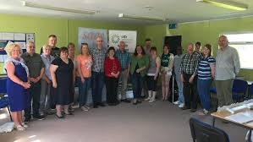 <https://www.google.com/imgres?imgurl=https%3A%2F%2Flh3.googleusercontent.com%2Fp%2FAF1QipNhYZXoqrKnWpKKy3Cqiy362c9zGIYA_4ejnQ9b%3Dw1080-h608-p-no-v0&imgrefurl=https%3A%2F%2Fmayo-sligo-leitrim-etb-adult-education.business.site%2F&tbnid=mEGs1ZgVAjKvsM&vet=12ahUKEwiF4PHw5fP7AhXFsicCHWJxCKIQMygoegUIARD3AQ..i&docid=ez_2Vh4Ayr5Y1M&w=1080&h=608&q=Mayo%20Sligo%20Leitrim%20ETB%20classes&hl=en&ved=2ahUKEwiF4PHw5fP7AhXFsicCHWJxCKIQMygoegUIARD3AQ>

Mayo Teagasc Training Centre - Ballinrobe



<https://www.google.com/imgres?imgurl=https%3A%2F%2Flookaside.fbsbx.com%2Flookaside%2Fcrawler%2Fmedia%2F%3Fmedia_id%3D489978569839883&imgrefurl=https%3A%2F%2Fwww.facebook.com%2Fteagascmayo%2F&tbnid=OrDtcLLaBdthwM&vet=12ahUKEwjCpM2P5vP7AhXibKQEHRowBPgQMygPegQIARBD..i&docid=LRJFAiez2TeXlM&w=2048&h=1536&q=Mayo%20Teagasc%20Training%20Centre%20-%20Ballinrobe%20classes&hl=en&ved=2ahUKEwjCpM2P5vP7AhXibKQEHRowBPgQMygPegQIARBD>

ATU - Mayo CampusÂ andÂ ATU - Atlantic Technological University classes

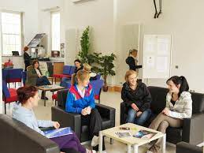 <https://www.google.com/imgres?imgurl=https%3A%2F%2Fwww.gmit.ie%2Fsites%2Fdefault%2Ffiles%2Fstyles%2Ftraditional_television%2Fpublic%2F2021-11%2Fgmit-mayo-campus-20130411-_kha0398.jpg%3Fh%3De30659eb%26itok%3DfF7W6MCI&imgrefurl=https%3A%2F%2Fwww.gmit.ie%2Fteaching-learning&tbnid=iil5OGf3r2k6jM&vet=12ahUKEwiw-4av5vP7AhULrycCHX9GBTQQMygAegUIARDAAQ..i&docid=GbiwxvcFro7x9M&w=960&h=720&q=ATU%20-%20Mayo%20Campus%C3%82%C2%A0and%C3%82%C2%A0ATU%20-%20Atlantic%20Technological%20University%20classes&hl=en&ved=2ahUKEwiw-4av5vP7AhULrycCHX9GBTQQMygAegUIARDAAQ>

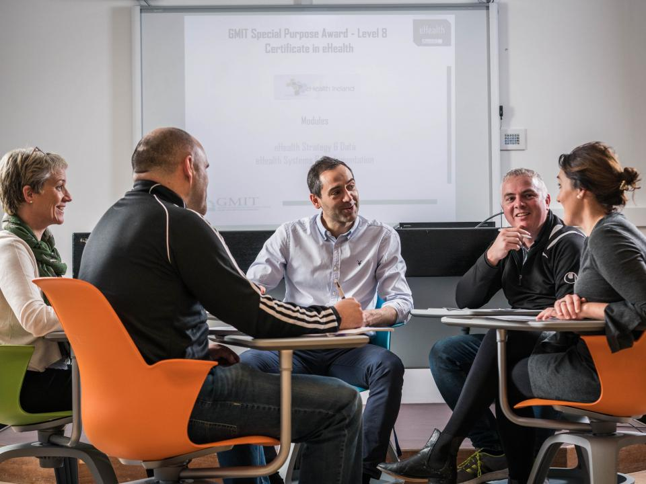

<https://www.google.com/url?sa=i&url=https%3A%2F%2Fwww.gmit.ie%2Fgmit-mayo-campus&psig=AOvVaw0ODmsP0y24Y0wd1r1cLftZ&ust=1670924876718000&source=images&cd=vfe&ved=0CBAQjRxqFwoTCODrq7Hm8_sCFQAAAAAdAAAAABAE>

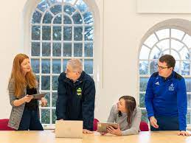

https://www.google.com/url?sa=i&url=https%3A%2F%2Fwww.gmit.ie%2Fgmit-mayo-campus&psig=AOvVaw0ODmsP0y24Y0wd1r1cLftZ&ust=1670924876718000&source=images&cd=vfe&ved=0CBAQjRxqFwoTCODrq7Hm8_sCFQAAAAAdAAAAABAJ